**University of Moratuwa**

**Department of Electronics and Telecommunication**

**EN3160 – Image Processing and Machine Vision**

**Report Activity 01**

**200356A**

**Q1.**

Figure 2 Code for the given transformation

Figure Image after the intensity transform

**Q2.**

1. A close-up of a brain scan

   Description automatically generatedWhite matter enhanced

Figure 3 Original image

Figure 4 White matter enhanced image

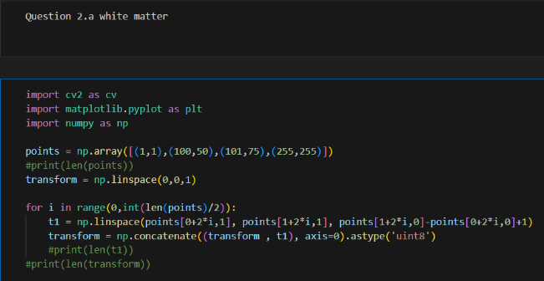

Figure 5 White matter enhancing transform

Figure 6 White matter enhancing transform code

1. 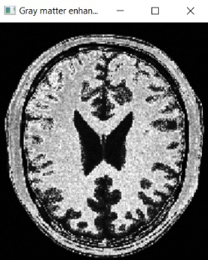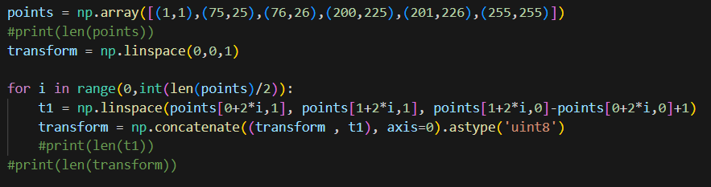A close-up of a brain scan

   Description automatically generatedGray matter enhanced

Figure 10 Gray matter enhancing transform code

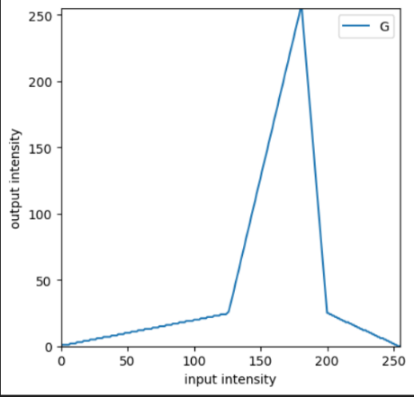

Figure 8 Gray matter enhanced image

Figure 7 Original image

Here, most black parts are not in gray matter.

Therefore, enhancement is done only for the

region where gray matter is.

This intensity transform will enhance the gray

matter area.

Figure 9 Gray matter enhancing transform

**Q3.**

Gamma value used = **0.6**

Q4.

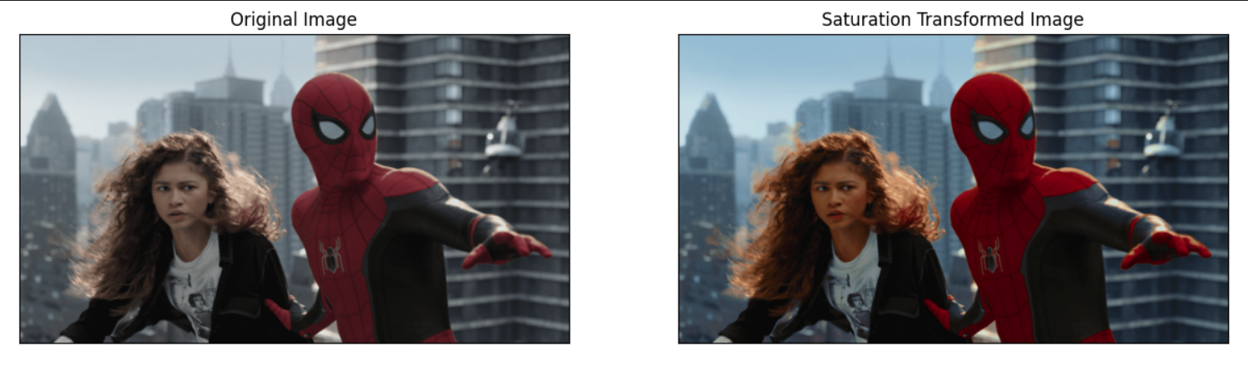

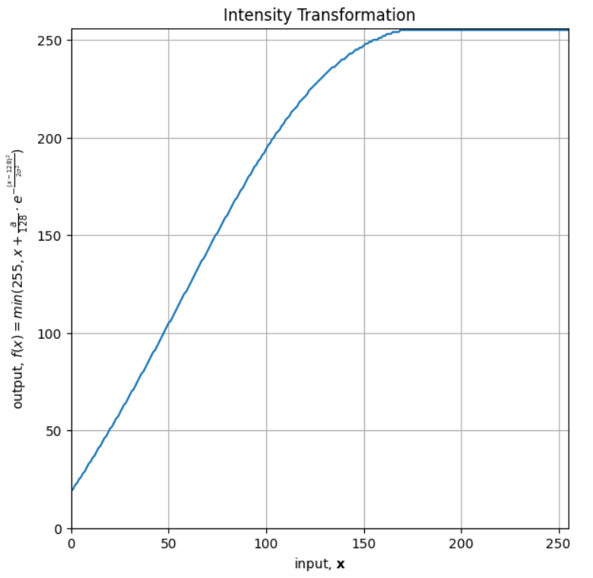

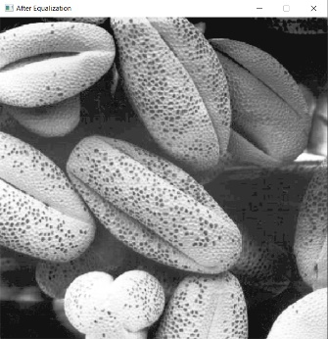Q5.

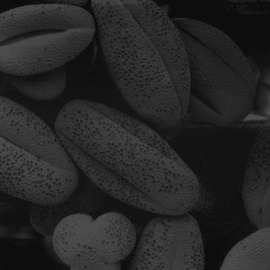

06.

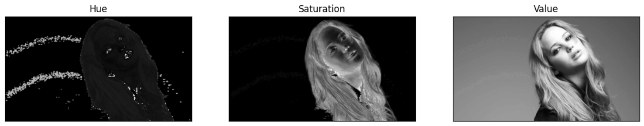

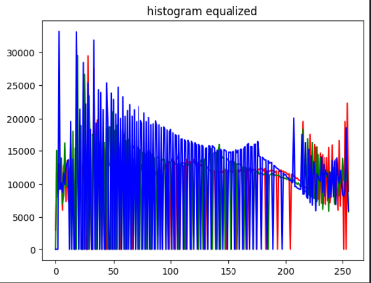

Q7.

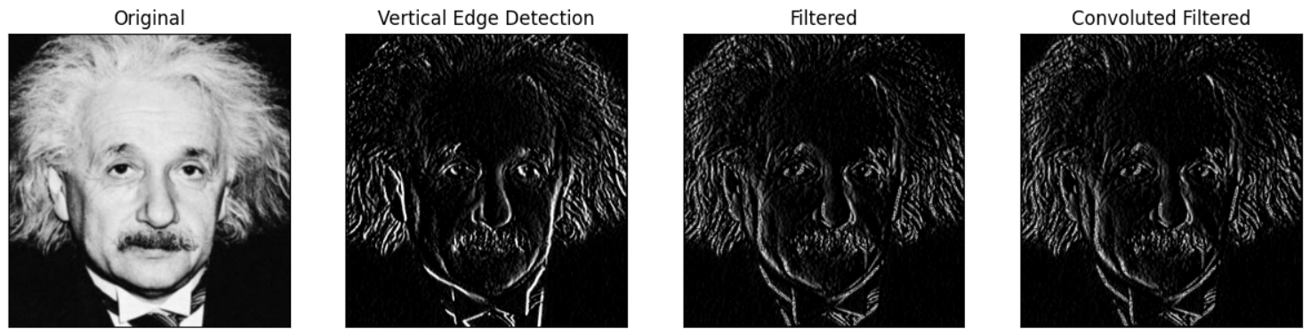

Q8.

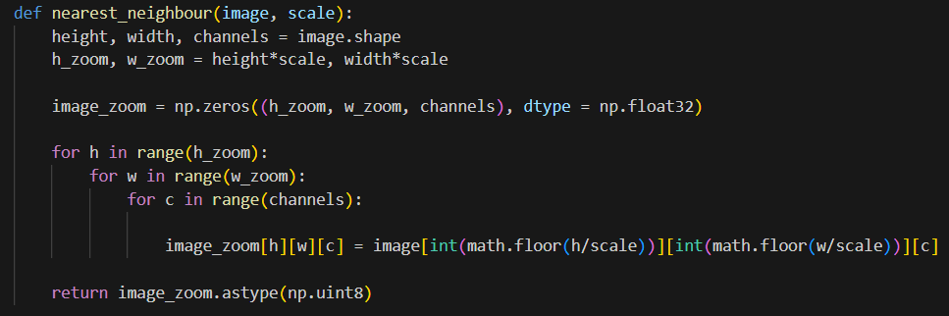

09.

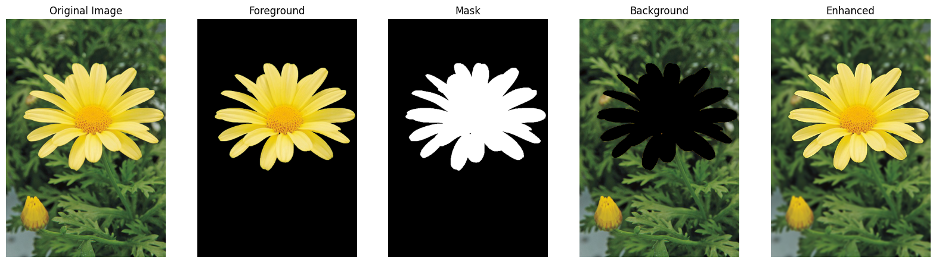

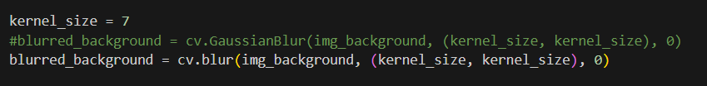

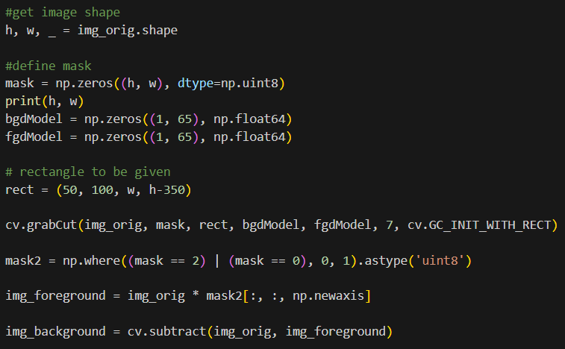

Once the background image gets blur, edge near the missing flower gets closer values to 0 as most of the pixels are 0. Therefore, image gets little darker.

**GitHub Link repo :** [**https://github.com/Dulan24/S5_EN3061_Image-processing**](https://github.com/Dulan24/S5_EN3061_Image-processing)

**Notebook link :** [**https://github.com/Dulan24/S5_EN3061_Image-processing/blob/master/Activity%2001/answers/codes.ipynb**](https://github.com/Dulan24/S5_EN3061_Image-processing/blob/master/Activity%2001/answers/codes.ipynb)